**DYNATRACE**

DynaTrace is an agent based APM solution that provides alerting and monitoring capabilities along with rich code analysis for .NET & Java applications across the entire software lifecycle. Currently we have 7.0 release of dynaTrace in market.

You can utilize the features of dynaTrace by installing dynaTrace from our site

[https://share.allstate.com/sites/APM/Perf%20Monitoring/Documentation/dynaTrace/dynaTraceClientConfiguration.docx](https://share.allstate.com/sites/APMPerfMonitoring/Perf%20Monitoring/Documentation/dynaTrace/dynaTraceClientConfiguration.docx).

Once Dynatrace client is installed you can add servers and start using Dynatrace with the help of the information and the quick review provided in the documentation. Beginning with the basic dynaTrace architecture.

**Dynatrace Architecture**

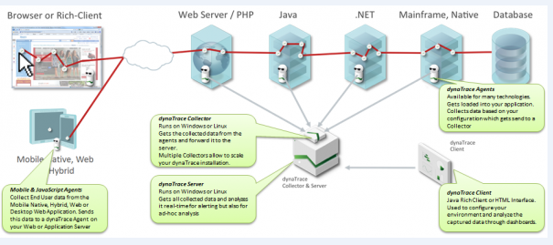

**DynaTrace Client**

The dynaTrace Client is the presentation layer installed on users' machines or you can start it via a browser, and load it from the Frontend.

Upon starting the Client a welcome page is shown where we need to add the application server for the monitoring. Once you have configured at least one, you will find the options given in the figure.

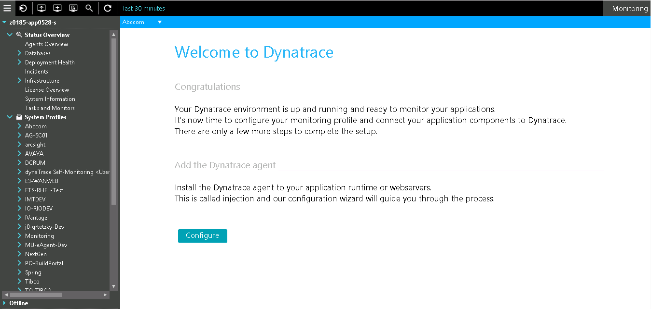

**System Profile**

A System Profile is the "workspace" where you administer a certain application environment. These are listed in the Dynatrace Clients cockpit and serve as one possible starting point for all interactive actions applied to the data. The data is provided by the Dynatrace Agents associated with the System Profile.

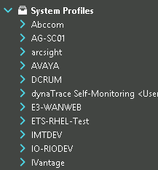

**Status Overview**

The Status Overviewnode in the Cockpit contains dashlets that provide overall information about your system.

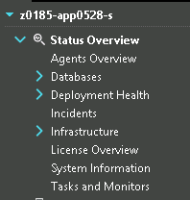

**Agents Overview**

The Agents Overviewprovides information on all Agents registered on the dynaTrace Server, including their properties and the appropriate deployed sensors.

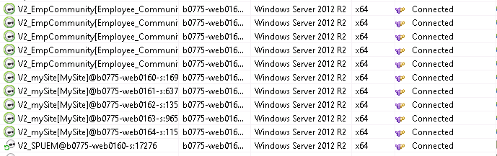

[**Incidents Overview**](https://community.dynatrace.com/community/display/DOCDT63/Incidents+Overview)

The Incidents dashlet is the entry point for managing and querying incident information across all [System Profile](https://community.dynatrace.com/community/display/DOCDT63/System+Profile)s. The following figure shows, the Incidents dashlet lists each incident rule that was violated.

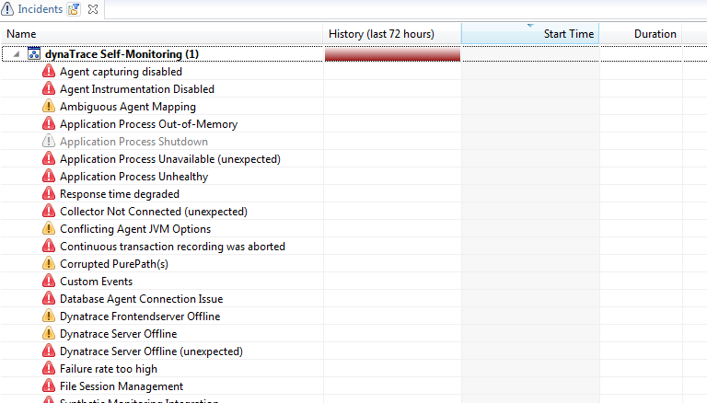

**Performance Specific**

Dynatrace offers multiple ways to analyze PurePaths. The Diagnose Performance node of a System Profile in the Cockpit lists the available performance-specific dashlets.

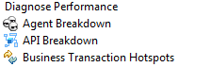



**Business Transactions**

You can keep track of business transactions (e.g. can see the track of number login action into the website). Basically business transaction comes with filter were we can define a specific URL / method. Filters are used to restrict the PurePath or user visit e.g. we can add a filter to see specific method, multiple filters can be applied also.

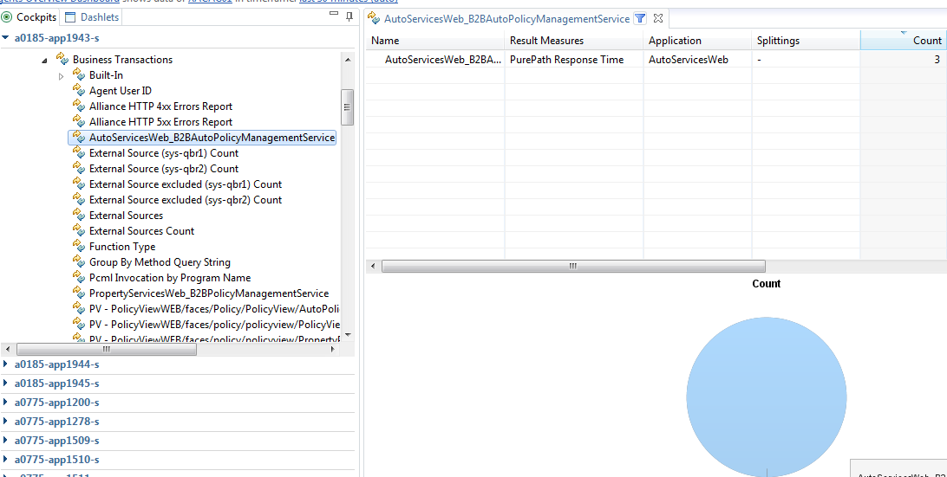

The pie chart in the dashlet visualizes the values of the currently selected column of the **Business Transactions** table. The figure shows the dashlet for the Business Transaction **Web Page Requests by URI**, with a chart for the **Count** values.

**PurePaths**

The **PurePaths** dashlet is the central representation of all captured PurePaths. You can use this dashlet to identify performance-critical methods and analyze their position within the PurePath, to recognize the cause of a performance problem.

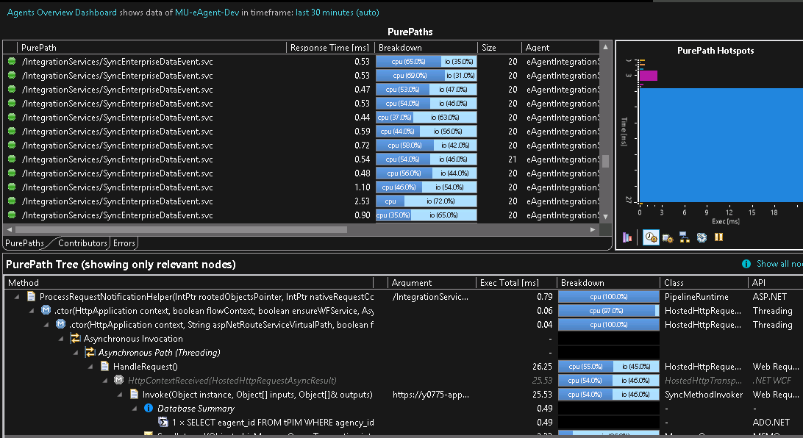

The **Tree** tab displays the contributors to the currently selected PurePath arranged as a tree that maps the calling hierarchy of the contributing methods. When you select a method in the **Contributors** tab, the PurePath tree scrolls automatically to the selected contributor method, and a yellow arrow appears to the left of that method.

**Web Services**

The **Web Services** dashlet displays performance metrics for web services.

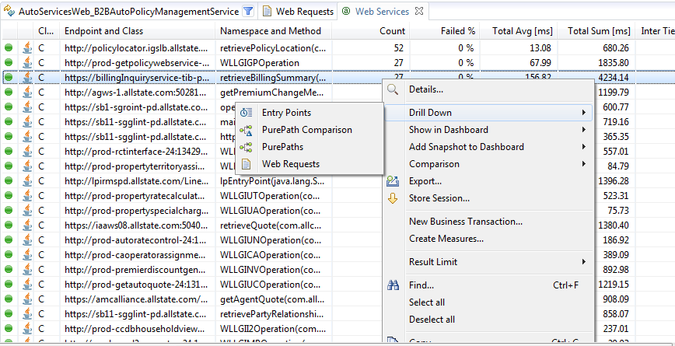

[**Event Specific**](https://community.dynatrace.com/community/display/DOCDT63/Event+Specific+Dashlets)

Dynatrace has many ways to handle events that are raised by the application or by monitoring. Select **Diagnose Events** in the Cockpit to get an overview via event specific dashlets.

[**Errors**](https://community.dynatrace.com/community/display/DOCDT63/Errors)

The Errors dashlet provides an overview of all errors that are detected in a specified time frame. For more information, see [Error Analysis](https://community.dynatrace.com/community/display/DOCDT63/Error+Analysis). The Errors dashlet is split into two parts like many other dashlets:

* Top - Displays configured error rules.
* Bottom - Displays details of a selected error category or error rule.

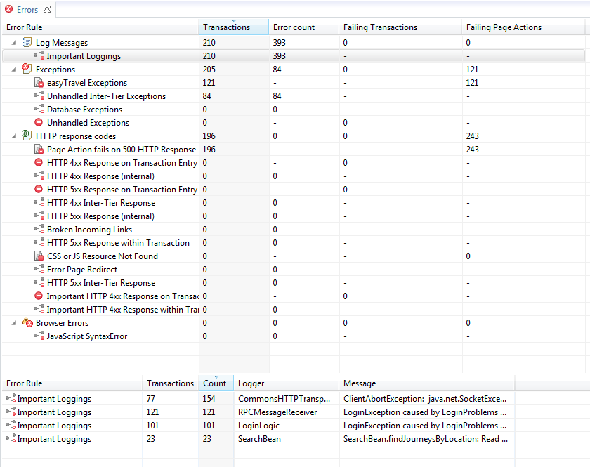

[**Exceptions**](https://community.dynatrace.com/community/display/DOCDT63/Exceptions)

DynaTrace uses a novel approach to diagnose exceptions. In Java, exceptions provide error-handling capabilities for application. DynaTrace makes use of dynamic byte code instrumentation to capture throwable classes, messages, and stack traces of java classes that extend java.lang.Execption.

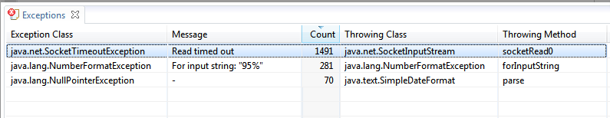

More options we have are for memory, threads

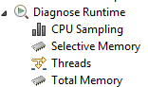

|  |  |
| --- | --- |
| [CPU Sampling](https://community.dynatrace.com/community/display/DOCDT63/CPU+Sampling) | Use the **CPU Sampling** dashlet to identify an entry point and to analyze background threads. |
| [Selective Memory](https://community.dynatrace.com/community/display/DOCDT63/Selective+Memory) | Use the **Selective Memory** dashlet to create or open snapshots and analyze the instances in the snapshot. |
| [Threads](https://community.dynatrace.com/community/display/DOCDT63/Threads) | Use the **Threads** dashlet to create or open thread dumps and analyze the thread stack. |
| [Total Memory](https://community.dynatrace.com/community/display/DOCDT63/Total+Memory) | Use the **Total Memory** dashlet for snapshot information about currently allocated objects, regardless of their connection to recorded PurePaths or configured memory rules. |

**TRANSCATION FLOW**

The Transaction Flow view shows the distribution of PurePaths over system components or tiers, monitored by distinct Dynatrace Agent instances. Components that are part of a selected PurePath execution are highlighted. PurePaths that span multiple components are represented by dashed lines between the components.

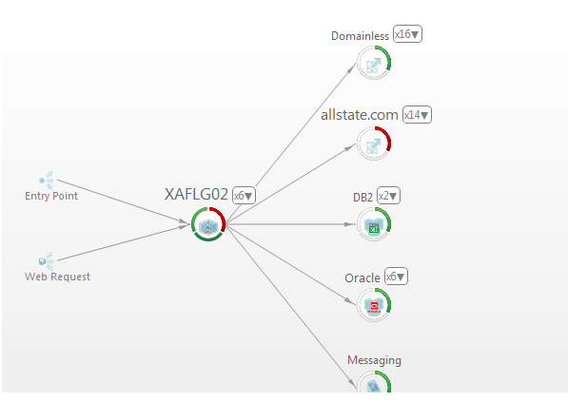

**Dashboard**

*Dashboard* provide a powerful tool for preparing diagnostic data for different kinds of use cases in the lifecycle of a software application. In the dashboards, you can filter, aggregate, and annotate PurePath-related information for experts in different fields.

To create dashboard follow the below steps:

Go to Dashboard 🡪New🡪 Use for Analysis

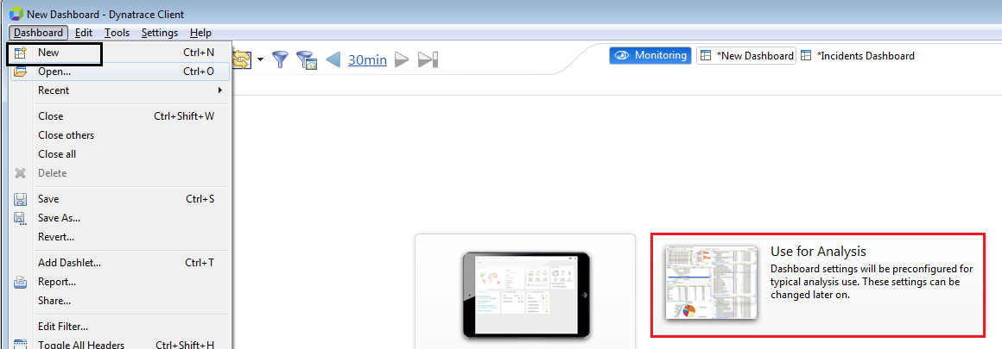

You will find the below given window .Select chart type e.g. Chart or dual axis chart🡪 Next

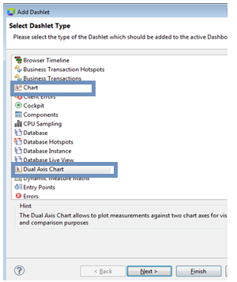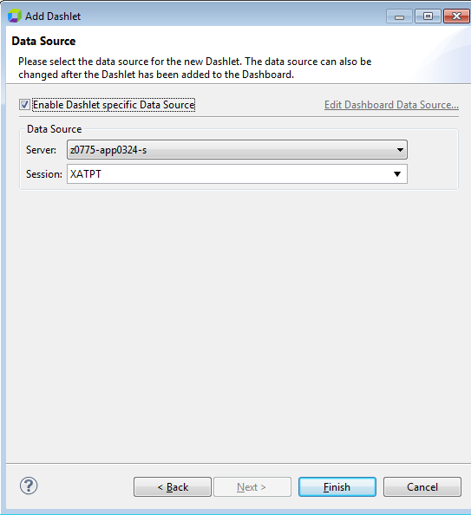

Provide server and the session name(System Profile) for which data is required and finish.

Click on Add series to add the measure

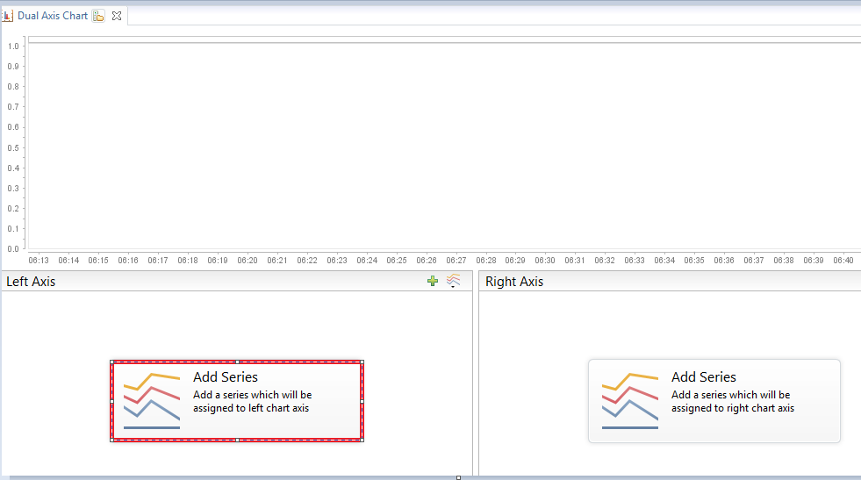

Use the Measure Picker dialog to select a series to represent in a chart. Click **Add Series** in the context menu of a chart.

Select the measure you want it on the dashboard and click **Add**

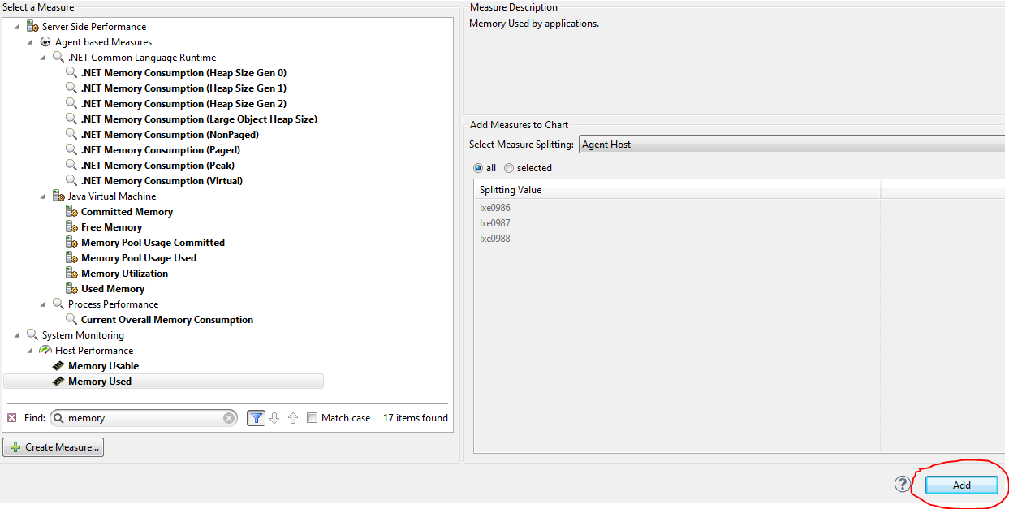

Dashboard is ready.

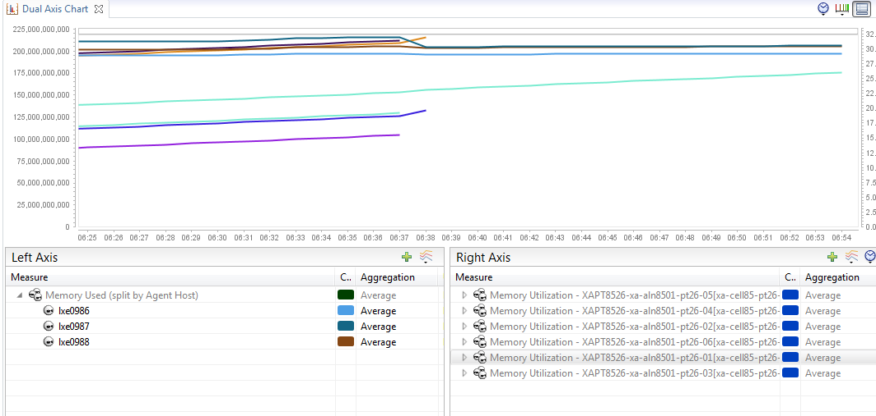

You can change the aggregation of the measure to the average, max, sum, and count by right clicking aggregation value. Resolution can also be changed options to the right top corner to change the time frame

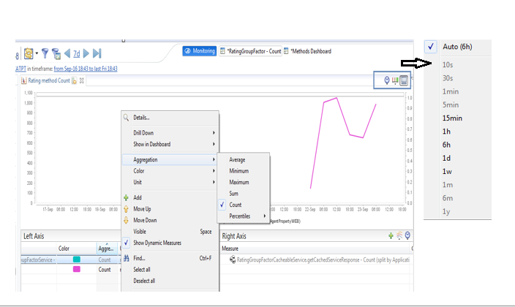

The dashlet properties can also be changed by right click dashlet name option

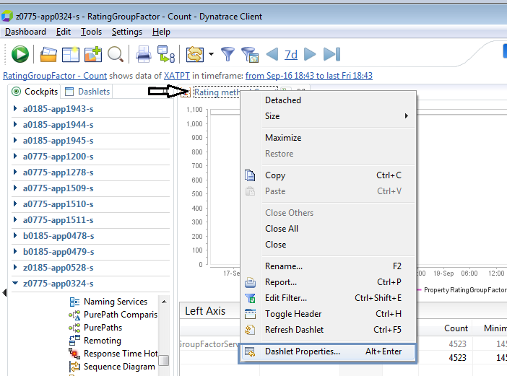

**Heat Field**

The heat field represents [incidents](https://community.dynatrace.com/community/display/DOCDT63/Incidents+Overview) that are triggered on Dynatrace Server.  
Use the default settings for the following:

* [Self-monitoring](https://community.dynatrace.com/community/display/DOCDT63/Incidents+and+Alerting#IncidentsandAlerting-ServerMeasuresandServerIncidents) incident rules.
* Incident rules that are based on charted Measures.
* User defined custom events (manually added).

Select individual incidents from the expanded heat field for more information. Double-click on an incident to drill down into the incident rule dashboard. Click the context menu for more drilldowns.

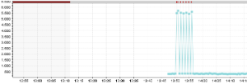

Hover above the heat field to automatically expand the field.

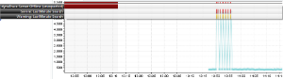

The heat field is enabled by default and appears at the top of the chart.

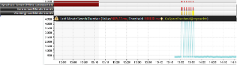

**Configuration**

To configure the chart heat field, open the context menu and click **Dashlet Properties > Heat Field tab.**

Chart Dashlet





